1. **INSTRUCTIONS**

* Template valid for both Annual Narrative Reporting & Project Completion Reporting.
* Annual Narrative Report (ANR) due at the end of the calendar year for ongoing multi-year projects. All questions in the template to be answered.
* Project Completion Report (PCR) due at the end of the multi-year support period, or at the end of the year in case of 1-year projects (instead of ANR). All questions in the template to be answered except Question 4 ‘Activity Forecast’.
* Refer to the [QPRG for MEAL](https://cbm365.sharepoint.com/:b:/r/sites/cbmnet/GlobalProgrammes/Documents/QPRG%20Monitoring,%20Reporting,%20Evaluation%20%26%20Learning.pdf?csf=1&web=1&e=5WhSSo) for detailed timelines, steps and responsibilities.
* Most important is to keep the report clear, concise, brief as possible and only as detailed as necessary. Limit number of pages as much as possible (Section III. NARRATIVE REPORT should ideally not exceed 5-10 pages).
* Delete the guidance under each question before submitting the report.
* The template can be adjusted by the Country Office (CO) as might be needed. Questions can be added or modified in line with donor needs.

1. **PROJECT DETAILS**

Complete the following table with respective project details (copy-paste as appropriate from last report):

|  |  |
| --- | --- |
| Project Number | 4081-MYP |
| Project Title | Grarbet Tehadiso Mahber Comprehensive Rehabilitation Programme in SNNPR |
| City/ Country/ Region | Butajera, SNNPR, Ethiopia |
| Project Duration | 01/01/2021 up to 31/12/2023 |
| Total approved budget amount (in EUR) | 75,000.00 |
| Total budget expenditure amount (in EUR) | 75,117.22 |
| Name of Contractual Partner | Grarbet Tehadiso Mahber> |
| Other Implementing Partners | None |
| Report contact person at Partner / Project | Mr. Teshome Tulu , Mr. Desalegn Amanuel and Prof. Redda Tekle Haimanot |
| Date of report submission | 15/1/2022 |
| Report contact person at CBM | Samuel Bekele, Programme Officer |

1. **NARRATIVE REPORT**

## **To what extent were the Objectives achieved?**

The specific objective of the project is to improve the efficiency and effectiveness of Eye Care, ENT, Epilepsy, and Physical Rehabilitation Services addressing persons with disabilities and at risk of disability in seven districts of the SNNP Region. GTM successfully achieved its objective by rendering quality medical and rehabilitation service during the reporting period. Furthermore, in collaboration with CBM and other donors, GTM re-activated its popular outreach eye care program for the marginalized poor beneficiaries who could not access the GTM Medical Rehabilitation Center. The project was able to implement planned activities as per the set schedule, and cost. There was no need to make any changes.

# **To what extent were the planned Results achieved or not during the reporting period?**

There has not been a reportable major adjustment in the result area and the major objectives of the project target has been achieved successfully. Due to support of CBM, people with visual impairment or at risk of visual impairment received comprehensive and inclusive eye care service. The beneficiaries are very much grateful to GTM and its partners for the quality medical and rehabilitation services they have received.

**Result 1: Targeted communities in central Ethiopia are provided with high-quality Eye care services**

Grarbet Tehadiso Mahber (GTM), with the help of CBM, provided comprehensive and inclusive eye care service using its base centers in Butajera and Batu. Beneficiaries from the project intervention districts of the SNNP and Oromia regions were screened and treated for major causes of preventable blindness namely Trachoma, Cataract, and Uncorrected Refractive Error (URE) during the period July to December 2022. Moreover, quality assurance measures for eye care services were put in place, in collaboration with CBM-CO, to ensure a favorable outcome of cataract surgeries. During the reporting period, 22,172 adults (Men: 11,860 and Women: 10,312) and 4,879 children (Boys: 2,505 and Girls: 2,374) were screened and treated for eye diseases.

**Result 2: Targeted communities in central Ethiopia are provided with essential ENT services**

GTM provided essential ENT services in rural central Ethiopia with specific emphasis on Ear and Hearing Care. It is worth noting that practically all government primary health care institutions do not offer a basic ear and hearing treatment to the rural population. Beneficiaries were screened and treated for common ENT problems using the GTM base center in Butajera. Additionally, GTM also organized, in close collaboration with Dr. Uta Froeschl of CBM and St. Paul’s Hospital Millennium Medical College (SPHMMC), surgical camps for patients needing advanced surgical intervention after obtaining negative Covid-19 results. The Covid-19 pandemic seriously affected the services being rendered. A total of 5,151 adults (Men: 2,560 and Women: 2,591) and 2,464 children (Boys: 1,232 and Girls: 1,232) were screened and treated for ENT problems.

**Result 3: Persons with disabilities in the targeted communities in central Ethiopia are provided with locomotor rehabilitation services**

Provision of physical rehabilitation services for persons with disability was one of the project’s main activities. GTM provided physical rehabilitation services in the form of physiotherapy together with the production and provision of assistive devices for persons with a disability using its base center in Butajera. Furthermore, GTM, using its workshop, also provided maintenance of assistive devices for persons with disability. This has created opportunities for persons with disability to become self-sufficient and productive. A total of 953 adults (Men: 483, Women: 470) and 420 children (Boys: 254, Girls: 166) were screened for physical disabilities.

**Result 4: patients with Epilepsy in central rural Ethiopia are provided with medical services**

Screening, treatment and follow-up of persons with Epilepsy has continued to be a crucial component of GTM’s comprehensive medical and rehabilitation care provided for the rural community in central Ethiopia. Within its center in Butajera, GTM operates an Epilepsy clinic that is run by a qualified Health Officer. A neurologist (Prof. Redda) is consulted on cases that require advanced management. A total of 138 children (Boys: 77 and Girls: 61) and 124 adults (Men: 64 and Women: 60) were newly enrolled in the epilepsy clinic.

# **What key Activities were implemented and what Activities were planned but not implemented in the reporting period?**

|  |  |  |
| --- | --- | --- |
| **Key Activity No.** | **Activity Name** | **Status, achievements, no. of beneficiaries** |
| 1.1 | Eye patients screened and treated | Achieved. No. of beneficiaries:-27,051 |
| 1.2 | Active Trachoma cases treated with TTC | Achieved. No. of beneficiaries:-27,515 |
| 1.3 | Cataract surgeries performed | Achieved. No. of beneficiaries:-1,108 |
| 1.4 | Adults and children screened for refraction and low vision | Achieved. No. of beneficiaries:-3,824 |
| 2.1 | Patients screened and treated for ENT problems | Achieved. No. of beneficiaries:-7,615 |
| 3.1 | Persons rendered with physiotherapy services | Achieved. No. of beneficiaries:-1,373 |
| 3.2 | Patients treated with PoP for Club foot | Achieved. No. of beneficiaries:-123 |
| 3.3 | Appliances and devices produced and distributed | Achieved. No. of beneficiaries: -489 produced & 348 maintained. |
| 3.4 | Orthopedic surgeries performed | Achieved. No. of beneficiaries:-10 |
| 4.1 | Newly enrolled patients with Epilepsy treated | Achieved. No. of beneficiaries:-262 |
| 4.2 | Patients with Epilepsy followed | Achieved. No. of beneficiaries:-3,073 |

**List of activities implemented during the reporting period (July-December, 2021)**

All of the planned activities were implemented. There is no reportable major activity changes and problem sought during the reporting period.

**Result 01: Quality eye care service provided**

* 1. ***Eye patients screened and treated***

During the reporting period, 22,172 adults (Men: 11,860 and Women: 10,312) and 4,879children (Boys: 2,505 and Girls: 2,374) were screened and treated for eye diseases. GTM tried to give more emphasis to the leading causes of visual impairment namely, Trachoma, Cataract, and Uncorrected Refractive Error (URE) during examination. GTM provided the service using its base Centers in Butajera and Batu, as well as the outreach clinics.

GTM has been recovering from the impact of the pandemic and the numbers of patients visiting the two centers have grown steadily. To mitigate the spread of COVID-19 during the screening of eye diseases, GTM follows standard COVID-19 safety protocol. Beneficiaries presenting to the two GTM centers were being tested for body temperature before the screening. Additionally, patients and relatives were strictly required to wear facemasks before entering the two premises.

* 1. ***Active Trachoma cases treated with TTC***

Out of the 27,051 patients screened, a total of 837 adults (Men: 373 and Women: 464) and 464 children (Boys: 233 and Girls: 222) were diagnosed as having active trachoma and were treated with TTC eye ointment. The number of patients who utilized GTM facilities showed improvement compared to the previous six months.

Patients with Trichiasis were also screened and operated during the reporting period. A total of 255 lid surgeries were performed. The number of TT surgeries performed by GTM has shown a significant improvement in the reporting year as compared to the previous year. This was because GTM re-activated its outreach eye care program following the fund obtained from SeeYou Foundation, a Dutch-based organization previously known as Light for the World Netherland. Furthermore, GTM in collaboration with CBM has also started two Trachoma projects in GTM operation districts.

* 1. ***Cataract surgeries performed***

Cataract surgery provision was one of the core activities of GTM Centers. During the reporting period, a total of 1,100 adults (Men: 537 and Women: 563) and eight children (Boys: 5 and Girls: 3) were operated for cataract. Emphasis was given to the selection, preparation, and outcome of patients operated for cataracts. Since most GTM beneficiaries come from distant rural villages, patients are admitted for three days to be monitored before, during, and following surgery to ensure a favorable outcome of surgery. The outcome of surgery procedures were indicators for the cataract surgery service, in addition to the number of surgeries performed. Periodic monitoring of the outcomes was therefore a key component of GTM clinical audit. GTM performed a mandatory Cataract Surgery Outcome Monitoring (CSOM) during the reporting period using the WHO standard. Results of the monitoring were encouraging. Efforts were being exerted to identify the cause of poor outcomes after an operation and devise strategies to maximize the level of visual outcome.

In addition to the routine service delivery, GTM was involved in the academic training Ophthalmologists in Ethiopia. Ophthalmology residents from St. Paul’s Hospital Millennium Medical College (SPHMMC) were attached at the GTM center in Butajera for hands-on training. Three residents (Male: 1 and Female: 2) stayed for a 6 weeks’ period.

* 1. ***Adults and children screened for refraction and low vision***

One of the flagship eye care initiatives of GTM is its integrated Optometry service. GTM optometrists continued providing refraction and affordable eyeglasses provision for the rural community in central Ethiopia. During the reporting period of six months, 3,700 adults (Men: 2,319 and Women: 1,381) and 124 children (Boys: 66 and Girls: 58) were screened for uncorrected refractive errors. Beneficiaries requiring eyeglass were provided with low-cost eyeglasses produced at GTM optical workshops.

**Result 02: Targeted communities in central Ethiopia are provided with essential ENT services**

* 1. ***Patients screened and treated for ENT problems***

GTM continued to provide advanced ENT care for the rural community in its operational and adjacent districts through its walk-in clinic at Butajera. During the reporting period, a total of 5,151 adults (Men: 2,560 and Women: 2,591) and 2,464 children (Boys: 1,232 and Girls: 1,232) were screened and treated for ENT problems. Out of the patients screened, 1,252 adults (Men: 612 and Women: 640) and 1,333 (Boys: 697 and Girls: 636) were treated for ear infections.

GTM performs audiometry for patients presenting to its center with hard of hearing and recurrent ear infections. During the reporting period, audiometry was performed for 358 adults (Men: 176 and Women: 182) and 60 children (Boys: 22 and Girls: 38). Unfortunately, GTM has no access to hearing aids.

GTM resumed its ENT surgical camp in collaboration with Dr. Uta Froeschl as part of the collaboration between GTM, SPHMMC and CBM. During the reporting period, 29 adults (Men: 15 and Women: 14) were operated for major surgical ear problems. Safety precautions were implemented to protect our patients and staff from Covid-19. Moreover, Covid-19 test results were obtained for the patients who underwent surgery.

ENT residents from SPHMMC also joined the surgical team for hands-on training. The residents' response has been overwhelmingly positive.

**Result 03: Persons with disabilities in the targeted communities in central Ethiopia are provided with locomotor rehabilitation services**

* 1. ***Persons rendered with physiotherapy services***

Providing locomotors and rehabilitation services to beneficiaries in rural central Ethiopia was an essential project activity of GTM during the period. Using GTM's base center in Butajera, a total of 953 adults (Men: 483, Women: 470) and 420 children (Boys: 254, Girls: 166) were screened for physical disabilities. The physiotherapist and his assistant rendered physiotherapy services for 1,967 new clients and 2,090 clients on active follow-up during the reporting six months. Appliances and assistive devices were provided (to be expanded under 3.3)

* 1. ***Patients treated with PoP for Club foot***

Patients with clubfoot were also treated at GTM rehabilitation unit using the Ponseti technique. In this regard, the rehabilitation team applied PoP for 123 clients needing the service. In addition to CBM, TTAF, Hope Walks also supported the clubfoot management program.

* 1. ***Appliances and devices produced and distributed***

Mobility appliances namely, crutches, braces, orthopedic shoes, ankle-foot orthoses (AFO), and Knee-Ankle-Foot orthoses (KAFO) were produced inside GTM orthopedic workshop for persons with physical disabilities. This would have enabled persons with physical disabilities to be self-sufficient as far as mobility was concerned. In the reporting period, appliances and locomotive devices were distributed for 377 adults (Men: 228, Women: 149) and 112 children (Boys: 58 and Girls: 54). Moreover, maintenance of appliances was done for 312 adults (Men: 154, Women: 158) and 36 children (Boys: 25, Girls: 11). The unavailability of Polypropylene, a raw material used for the production of braces and orthoses, has been a concern for the production of mobility appliances.

* 1. ***Orthopedic surgeries performed***

GTM provided corrective surgical treatment and rehabilitation to 10 beneficiaries (Boys: 6 and Girls: 4) during the year. These were mainly children with clubfoot. The surgery was performed by GTM Orthopedic Surgeon, Dr. Getahun Yitbarek.

**Result 04: Patients with Epilepsy in central rural Ethiopia are provided with medical services**

GTM's core activities for the reporting period included providing care and treatment to people with epilepsy. A total of 138 children (Boys: 77 and Girls: 61) and 124 adults (Men: 64 and Women: 60) were newly enrolled in the epilepsy clinic. Additionally, a total of 1,344 children (Boys: 584 and Girls: 760) and 1,729 adults (Men: 773 and Women: 956) visited the epilepsy clinic for an active follow-up. The high cost of medicines for the treatment of Epilepsy continues to be a major challenge for the patients. This also applies even for the cheapest epilepsy drug, phenobarbitone. There are periods when it is total absent in the country.

## **Activity Forecast (only for ANR)**

**List of activities planned to implanted in the coming reporting period from Jan-December,2022**

**Result 01: Quality eye care service provided**

1.1 Eye patients screened and treated

1.2 Trachoma cases treated with TTC

1.3 Lid surgeries performed

1.4 Cataract surgeries performed

1.5 Adults and children refracted

1.6 Adults and children provided with spectacles

**Result 02: Essential ENT services provided to rural people in central Ethiopia**

2.1 Screening and treatment of patients for ENT problem

2.2 Treatment of patients for ear infection

2.3 Removal of the foreign body for 450 adult and children patients

2.4 Audiometry for persons with Hard of hearing

2.5 ENT surgeries performed

**Result 03: Persons with disability screened**

3.1 Screening of persons with disability

3.2 Persons with disability rendered with physiotherapy service

3.3 Appliances and devices produced and distributed

3.4 Orthopedic surgeries performed

3.5 Appliance and devices maintained

**Result 04: Medical services provided to patients with Epilepsy in rural central Ethiopia**

4.1 Newly enrolled patients with Epilepsy treated

4.2 Patients with Epilepsy followed

**Result 05: Provide compressive ranges of LV services**

5.1 Low vision screening of children and adults

5.2 Provision of appropriate LV devices and materials to enable persons with low vision to benefit from their remaining vision

5.6 Train teachers on how to identify with low vision and on class room arrangement

# **Internal or external organizational challenges or changes that have affected project implementation during the reporting period**

Dr Zerihun Hailu, who was GTM’s Medical Director and senior Ophthalmologist, recently resigned from our organization. Dr Zerihun worked for more than five years before leaving in his own accord. He is now replaced with Dr. Addishiwot.

|  |  |
| --- | --- |
| Challenge | Lessons learned / solutions |
| High prices of medicines and unavailability of IOL | The high price of medicines and unavailability of IOL (18-24D) was a major concern for this project. GTM performed more than 3,000 cataract surgeries in 2021 using its two base Centers in Butajera and Batu. This shows that there was a large and unmet need for cataract surgery in Ethiopia. In order to provide high-volume and quality cataract surgery, GTM requires assistance from CBM-CO and other partners for the supply of IOL and other essential medicines. |
| Unavailability of polypropylene, a raw material, for the production of braces for persons with disability. | Over the last three years, this has been a major obstacle to the production of mobility appliances due to the fact that GTM secured annual supplies of Polypropylene from Arba Minch rehabilitation centre in March 2021.Hence, unavailability of Polypropylene and high cost for the production of crutch handles make it difficult to provide assistive devices for persons with disabilities. |

1. **Implementation of actions agreed during previous monitoring visits, assessments, thematic discussions, etc.**

* As applicable, refer to any agreed action from:
  1. Project monitoring visits
  2. Evaluations (Evaluation Management Responses)
  3. Audits
  4. Partner Assessments
  5. Technical initiative assessments
  6. Disability Inclusive Development
  7. Gender
  8. Safeguarding of Children and Adults at risk
  9. Environmental protection
* List the actions and describe if, how and when they have been / will be addressed. Explain if or how the recommendations have benefited project implementation.
* In case this information is already provided elsewhere (e.g. as Annex to this report, or in other CBM reports) do not duplicate. Only make a reference to the respective separate report or Annex.

The project was designed and implemented according to Gender, Child, safeguarding and sustainability policy of GTM. No particular incident was encountered during the reporting period. Adults at risk were included in GTM’s child protection/Safeguarding policy. Efforts were made to incorporate the insight shared by Samuel Bekele, Programme Officer at CBM-CO, following his two days monitoring visit in September 2021.

## **Programmatic, financial and organizational sustainability**

The project's long-term viability has been largely dependent on community participation, stakeholder engagement, and institutional service delivery mechanisms. GTM has built a good reputation among stakeholders with whom it has engaged over the last two decades, thanks to its strong community foundation. In GTM's fight against preventable blindness, communities have been in the forefront. GTM was also involved in income-generating efforts that will aid the project's ability to sustain Post-CBM funding. Patients are required to pay small fee to get medical services such as for eye examination, major surgeries and also eye glasses. GTM also involves in another income generating schemes like bee keeping and zoo. Though we are generating significant amount of money from this activities, it still need support from CBM and other partners to sustain the service and provide quality medical and rehabilitation service.

## **Lessons learned and/or good practices**

Successful and sustained quality assurance and improvement interventions are paramount for delivering quality health service. The ongoing cataract surgery outcome audit, Cataract Surgery Outcome Monitoring (CSOM), in both GTM centers has been enabling to critically assess the quality of eye surgeries and design improvement interventions.

## **Collaborating Partners and Stakeholders**

|  |  |
| --- | --- |
| Partner / Stakeholder | Relationship update |
| FMoH, Regional, Zonal and Woreda Health Offices | Planning implementation and evaluation of activities are conducted in close collaboration with government line departments. |
| Bureau of Finance and Economy | GTM signed a project agreement with the regional Bureau of Finance and Economy. The Bureau in return assisted GTM in the project implementation and evaluation. |
| Saint Paul Hospital Millennium Medical College (SPHMMC) | SPHMMC donated ENT operation sets for the newly constructed ENT operation theatre. In return, GTM is hosting Ophthalmology and ENT residents from SPHMMC for hands-on training at GTM Butajera. The ophthalmologist residents are performing cataract under close supervision of GTM’s senior ophthalmologist. The ENT residents are also getting hands-on training in collaboration with CBM’s Dr. Uta. |

## **Overall partnership experience and feedback to CBM**

Our working relationship with CBM CO and its Programme and finance focal persons for the project has been strong and very good The focal persons were cooperative and their swift reply for our requests made the project a success.

1. **ANNEXES**
   * 1. **Photos**
   * Use this space to paste any latest photos with captions, news items etc. related to the project.
   * Ensure that written consent has been obtained from all identifiable people in the photos. If needed, Consent Forms for filling in and signing can be requested from CBM at any time.

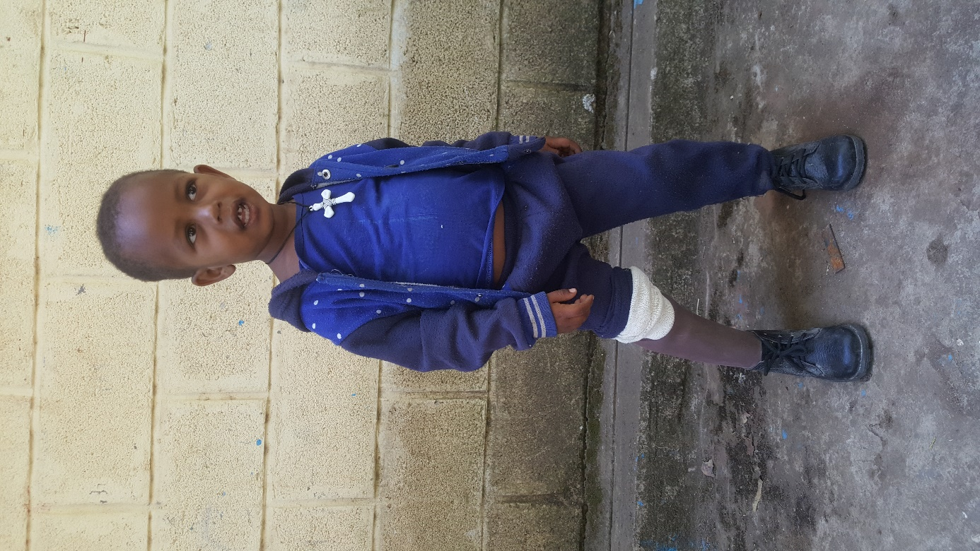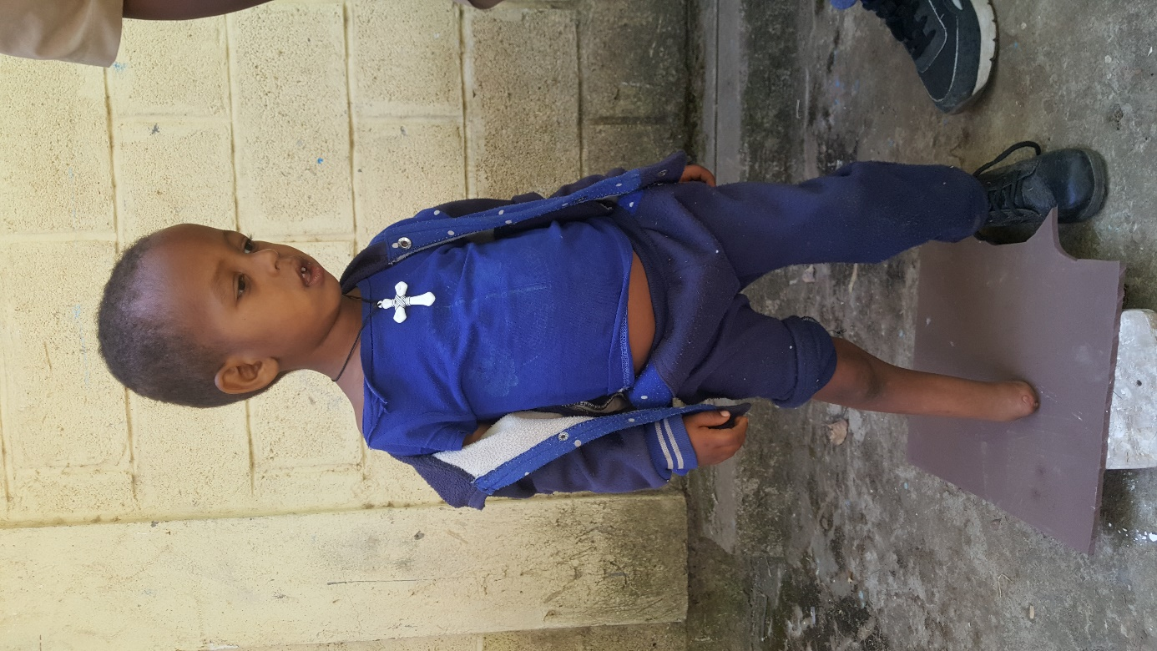

**Figure 1: A child from GTM’s Operational District wearing his newly-fitted assistive device**

* + 1. **Stories of Change**

**Tirngo Andarege**

Tirngo Andarege, 20, is a student from Butajera, Southern Ethiopia. She was in excruciating pain and had pus draining from her right ear. She came to get treatment after hearing about her relative's positive experience in the GTM center. The examination revealed that she developed perforation of her eardrum leading to hearing loss. GTM in collaboration with SPHMMH and CBM has organized surgical camps in the GTM center during the reporting period. The surgical team led by Dr. Froeschl performed minimally invasive ear surgery, tympanoplasty. Tirngo recovered well after surgery, and the tympanic membrane in her right ear was fully sealed. Three months’ post-surgery, she had another audiometry test. The hearing test showed that her hearing is improving. “Before the surgery, I had to be careful not to get water in my ear when I showered. My hearing ability was also affected. The surgery changed my life. It has been the best thing ever.” Tirngo says.

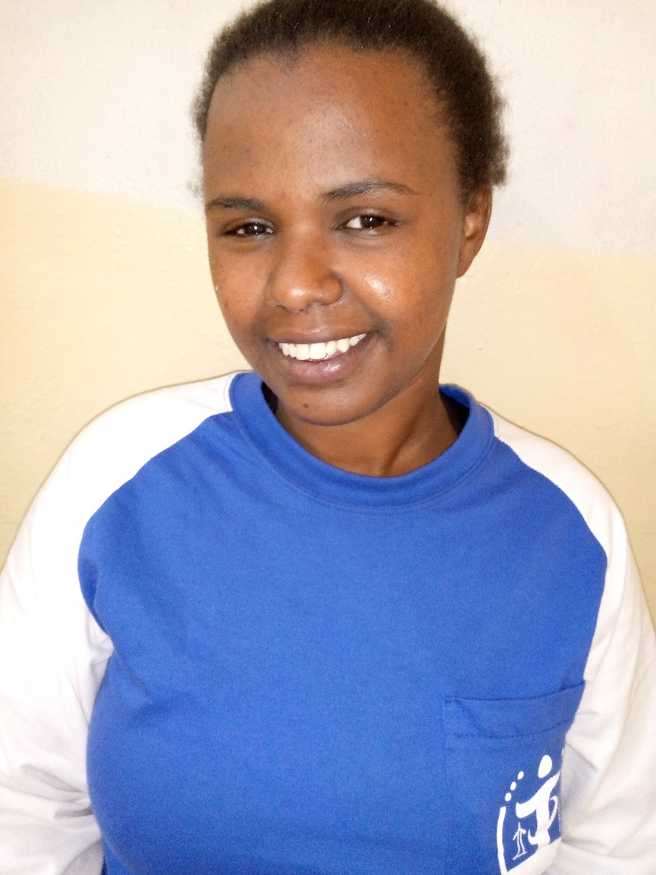

**Figure 2: Tirngo during the follow-up visit**

**Hantute Genemo**

Hantute Genemo is a mother of six children from Bulbula town, Adame Tulu District, Oromia Region. Her son brought her to GTM Center when his mother complained of poor vision in both eyes. He found out about GTM eye care service from neighbors who had previously utilized it. The examination revealed that she had a lazy left eye that could not be improved with treatment, and a dense cataract in the right eye was discoverd. The vision got so bad she had to remain at home. She was also struggling to do basic things, such as cooking and cleaning her home. Since the cataract was clouding her vision, the ophthalmologist recommended surgery. During the surgery, the cataract was removed and the [natural eye lens](https://www.aao.org/eye-health/anatomy/lens-9) is replaced with a thin, permanent artificial lens, called an [intraocular lens](https://www.aao.org/eye-health/diseases/cataracts-iol-implants). She was admitted for three days to be monitored before, during, and after surgery to ensure a successful outcome. Hantute was surprised by the immediate improvement in her vision and thanked GTM staff for life-changing surgery.

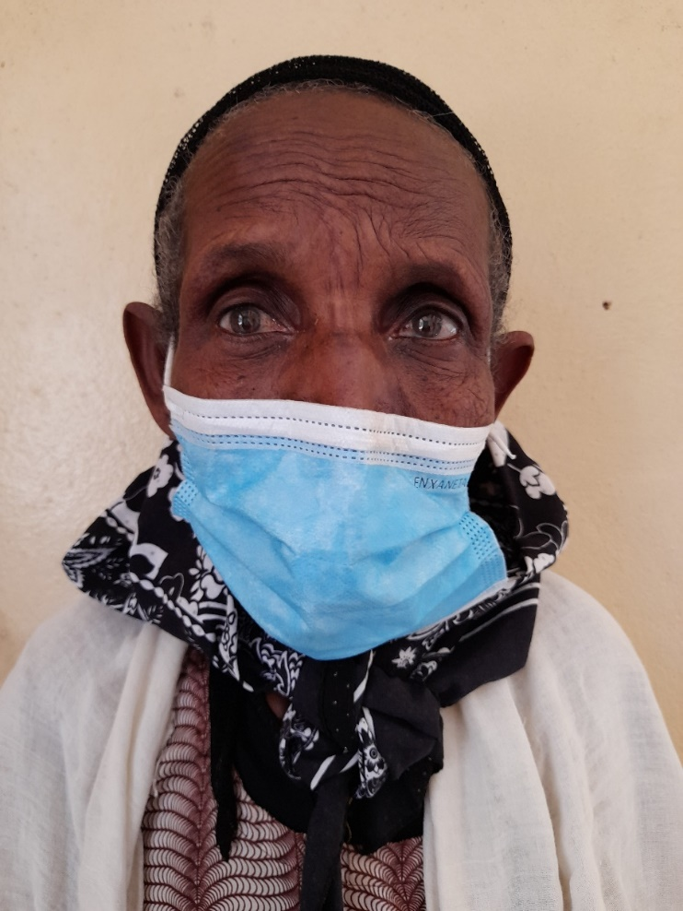

**Figure 3: Hantute with mature Cataract on her right eye**

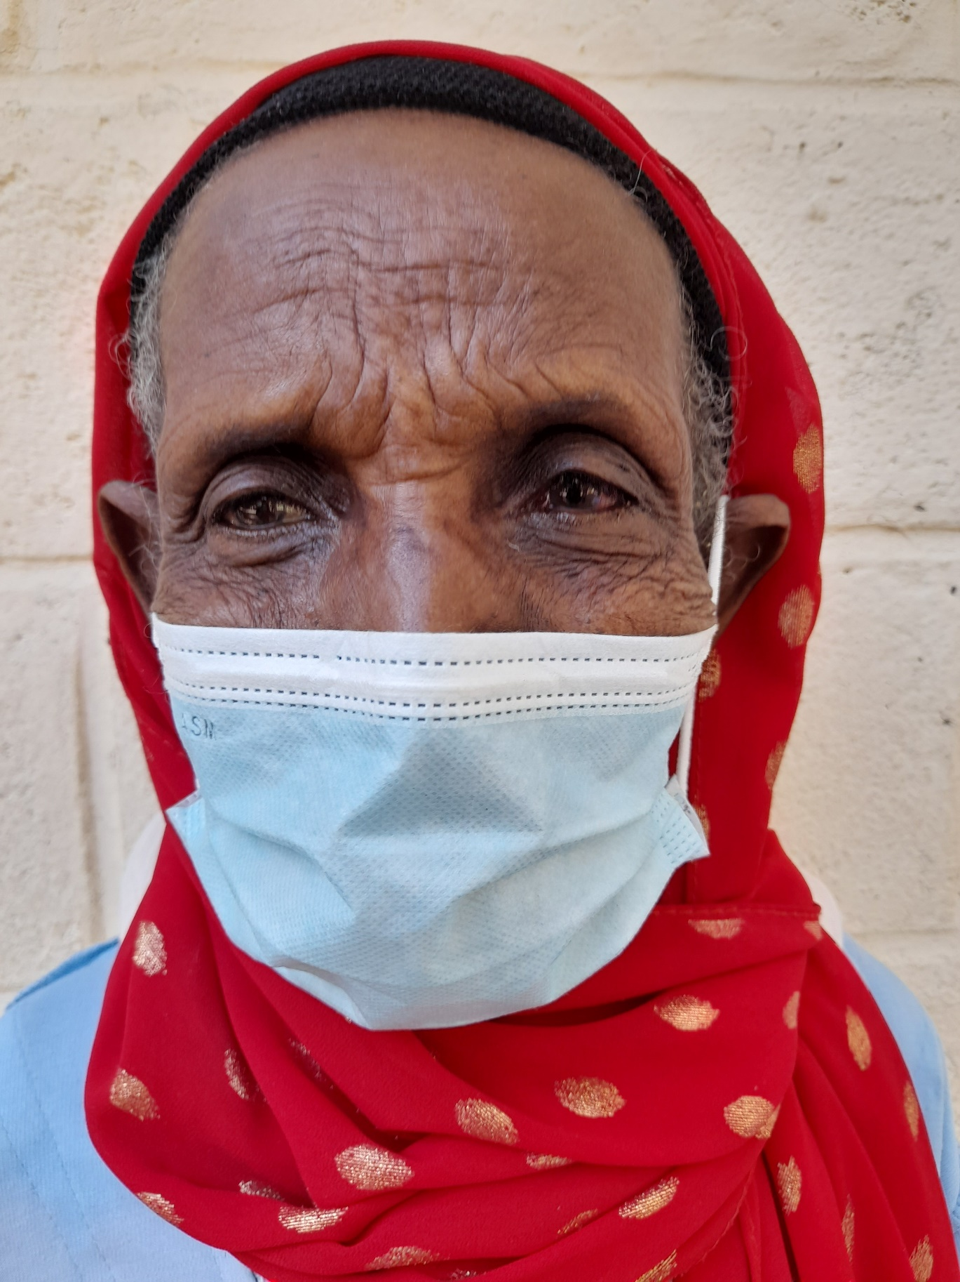

**Figure 4 Hantute after her right eye vision is restored**

* + 1. **Updated Partner Assessment Action Plan**
    2. **Updated Project Risk Register**
    3. **Any other supporting documents as needed or agreed with CBM**

1. **COMMENTS FROM CBM**

Grarbet Tehadiso Mahber known as GTM has long been one of the strong partners of CBM CO with good track record of successful project implementation to ensure mutual success of benefiting a large number of inaccessible people with quality inclusive comprehensive medical rehabilitation services through implementing Multi Year projects over the years.

Over the reporting period, the partner was communicative, accessible, effective, and efficient to achieve the intended results as per the key performance indicators which determines the intended results. The partner was successful to achieve implementing planned activities in all the result areas. The result areas included 1. Targeted communities in central Ethiopia are provided with high-quality Eye care services 2. Targeted communities in central Ethiopia are provided with essential ENT services 3. Persons with disabilities in the targeted communities in central Ethiopia are provided with locomotor rehabilitation services, and 4. patients with Epilepsy in central rural Ethiopia are provided with medical services. In each result area, they were able to reach out targets set for the year in spite of challenges due to COVID-19 pandemic which delayed some of planned activities, particularly the surgery procedure at ENT for EHC which was performed by Dr. Uta Froeschl (CBM ENT Surgeon seconded at St Paul’s Hospital Millennium Medical College in Addis Ababa). The target beneficiaries include men, women, boys and girls with the elderly people took the biggest number. Budget utilization was nearly more than 100%. The funds were being spent as intended, and achieved fairly the required result.

It delivered timely reports expected annually which included finance, narrative, Cataract Outcome, and statistics. The reports’ quality was up to the required quality standard. However, my general few recommendations to make in order to increase the reports quality considers the following points:

* It should be able to add supportive evidence at few areas by supplying outcomes of the service to make the report lively e.g. if sunglasses are distributed, quality of life improved due to the intervention should be indicated as patients’ feedback/satisfaction (things the beneficiary could not do before but could now do because of the intervention).
* Be able to make sentence description patient focused as well, apart from making it disease/impairment/activity focused.
* Be able to use active voice than passive e.g we enrolled 20 people instead of 20 people were enrolled
* Good to use past tense or present perfect tense instead of simple present tense. We provided instead of we provide

By and large, with continued support from the CO, the partner, with its well experienced staffs could maintain its good track record of effectively and efficiently managing Multi Year projects while addressing compliance issues from CBM.

-End of document. Back to top-